General Chapter 4

P = IE
E = IR
By Substitution
P = I²R
P= E²/R
E= √ PR
Three questions use these equations. Plug and Chug G5BO3, G5BO4, G5BO5, G5B12
--
Two times increase or decrease in power is a change of 3db.

1 db is 20.6%
--
AC voltage is measured in a RMS of the sine wave. The effective AC voltage. 120 VAC from the outlet is a RMS value. In a pure resistive circuit, this RMS value is equivalent to 120 DC. The actual sine wave have other points of magnitude.

The RMS value of AC has the same power dissipation as the same value of DC into the same resistive load. G5B07

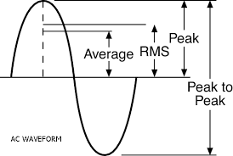

RMS value = .707 x Peak value
Peak value = 1.414 x RMS value G5B09

PEP = Peak envelope power. The max PEP RF power we can transmit is 1500 Watts.

Average AC power = RMS voltage ² / Load impedance
PEP = E_{RMS}² / R

SERIES CIRCUITS
The current entering the circuit is the same throughout the circuit.
All voltage drops throughout the circuit add up to the supplied voltage.
PARALLEL CIRCUITS
The current entering the circuit is divided between the parallel legs of the circuit.
The current entering and leaving the circuit is the sum of the individual currents in the legs.
RESISTORS
Series resistors. Same current flows through all resistors
Total resistance (R_{t})in a series resistor circuit = the sum of all the resistances

Parallel resistors. The current is divided between each resistor.
Total resistance in a parallel resistor circuit is less than the lowest resistor value. (Hint, but not ridiculously less)
Total resistance (R_{t}) in a parallel resistor circuit. R1 X R2/R1 + R2 for two resistors or the reciprocal of the sum of the reciprocal of each resistor.
______________1________________
1/R1 + 1/ R2 + 1/R3 + 1/R ……

Test hint. To calculate R_{total}, a multiple of resistors of the same value in a parallel circuit divide the value by the number of resistors

CAPACITORS
(calculate opposite of resistors)

Capacitors in series. Less than the lowest capacitor value.
Total capacitance in a series circuit =

Or C₁ X C₂ / C₁ + C₂ for two capacitors in series.

Test hint. To calculate C_{total}, a multiple of capacitors of the same value in a series circuit divide the value by the number of capacitors.

Parallel capacitors
The value is the total of all of the capacitors in the parallel circuit.

C₁ ₊ C₂ + C₃ …..

INDUCTORS

Total inductance calculates the same as resistors.

TRANSFORMERS

Two inductors or coils physically connected but not electrically connected.
The voltage of one coil is induced into the coil of the other. (mutual inductance)
The primary winding is the input.
The secondary winding is the output.
The ratio of the turns is the ratio of the input and output voltage Transformers only work with AC

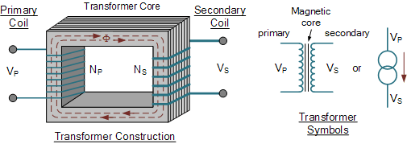

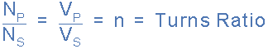

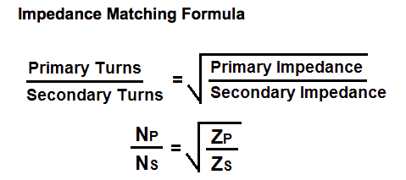
Or the square root of the turns ratio

