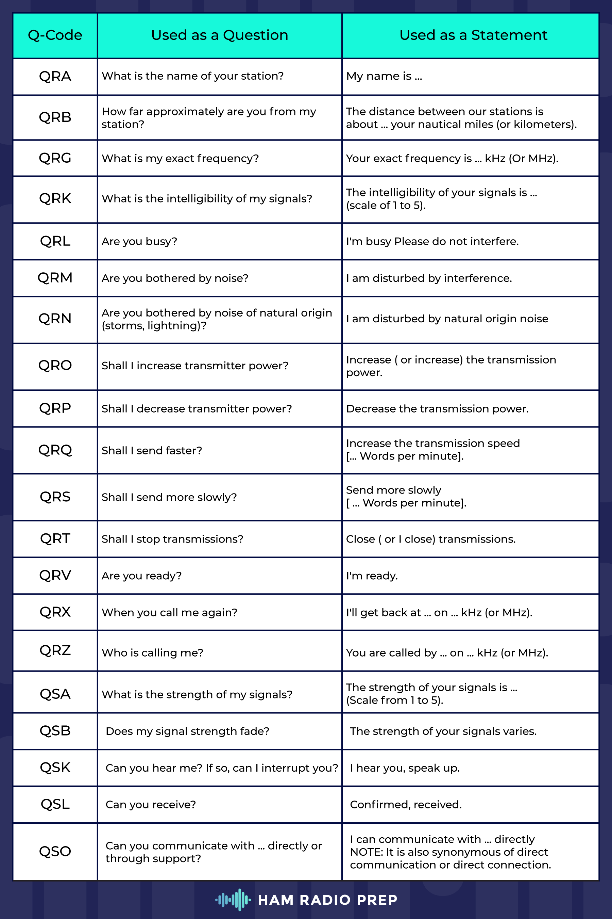

HAM Radio Acronyms
Acronym | Meaning
RF | Radio Frequency
Hz | Hertz - unit defined by cycles per second
kHz | Kilohertz
MHz | Megahertz
SW | Shortwave
HF | High Frequency
VHF | Very High Frequency
UHF | Ultra High Frequency
SWL | Shortwave Listener
Op | Operator
HAM | That would be YOU�LOL
VFO | Variable Frequency Oscillator - Adjust frequency to tune your radio
MR | Memory Record - Local memory on your radio for you to program and recalkl for working repeaters and simplex frequencies
TXP | Transmit Power - Output setting for your radio
VOX | Voice Operated Switch - Voice Activated keying so you can be hands free
SQL | Squelch - Controls and turns off output until incoming transmission overrides the setting parameters
TDR | Dual Watch - Allows your radio to listen to two channels.
CTCS / CTCSS | Continuous Tone Coded Squelch - Used on repeaters and your radio to control receive and transmit squelch
DCS | Digital Coded Squelch - Allows radio to tune out signals that are not using a tone
PTT | Push to talk - the button you depress to speak on the radio
BCL | Bust Channel Lockout - When enabled, prevents radio from tranmitting when another signal is present
F/MW | Function.Memory Write - Multi-function button for menus and writing to mem channels on Yaesu radios
BCN-TX | Beacon Transmit - If using APRS, this transmits your APRS beacon
AGC | Automatic Gain Control - keeps audio levels constant
ATT | Attenuator - Knocks down large signals to prevent receiver overload
CAT | Computer Assisted Transceiver - Provides computer control of your station to make it easier to use digital operation
NB | Noise Blanker
NF | Notch Filter
MUF | Maximum Useable Frequency - Highest frequency between two points where communication is possible
LUF | Lowest Useable Frequency - The lowest frequency between two points where communication is possible
SFI | Solar Flux Index - Amount of solar spots on Earth facing the sun
A Index | the daily average level for geomagnetic activity
K Index | a 3 hour interval of geomagnetic fluctuations
D Layer | The lowest of the ionospheric layers. 25-55 miles up called the "daylight layer"
E Layer | The next ionospheric layer which is about 55-90 miles up also referred to as a Daylight layer
F1 Layer | Second to the highest ionisperic layer is about 90-150 miles above the Earth
F2 Layer | The highest layer that is over 250miles above the earth
CW | Continuous Wave - This mode is used to transmit morse code
AM | Amplitude Modulation - Voice Mode
SSB | Single Side band
USB | Upper Side band
LSB | Lower Side band
FM | Frequency Modulation
D-Star | Digital Smart Technologies for Amateur Radio (ICOM Radios)
DMR | Digital Mobile Radio
APRS | Automatic Packet Reporting System - Offers real time digital communications of information in local area
Coax | Coaxial Cable used to connect antennas to radios, etc
SO239 | connector for UHF Radios SO indicating Socket
PL259 | connector for UHF Radios PL indicating Plug
BNC | Bayonet Neill-Concelman - twist lock antenna connector reliable up to 2GHz
SMA | Subminiature Version A - A threaded connector on HT radios and antennas good for 0Hz - 40GHz
Type N | Another connector type gott for frequencies up to 10GHz
SWR | Standing Wave Ratio - a measurement of the difference of impedance of your antenna connector and antenna feedline connection
Balun | Balanced/Unbalanced - allows interfacing antennas to coax to reduce feedline interference to your radiation pattern for the antenna
Unun | Unbalanaced/Unbalanced - allows interfacing antennas to coax to reduce feedline interference to your radiation pattern for the antenna
RST | Readability, Signal Strength, Tone
RTTY | Radio Teletype
ARRL | Amateur Radio Relay League
ARES | Amateur Radio Emergency Service
RACES | Radio Amateur Civil Emergency Service
SOTA | Summits on the Air - Make four contacts from an approved summit
POTA | Parks on the air - Make 10 contacts from an approved park

